STEPS FOR INSTALLATION AND SETUP OF CENTOS FILE AND PRINT SERVER
ISEC3700 - ASSIGNMENT 5

NSCC INSTITUTE OF TECHNOLOGY
5685 LEEDS ST
HALIFAX, NS B3K 2T3

NOVEMBER 9, 2018

Contents
Activity List 2
Reference Figures 6
VM Setup Figures: 6
CentOS Installation Figures: 8
Samba Setup Figures: 12
Cups and Printing Setup Figures 13
Nagios Setup Figures 16
Assignment Questions 19
References 21

Activity List

Here’s an overview of the structure of this assignment:

Activity List
Project: Installation and Setup of CentOS File and Print Server |  | Date: Nov 23, 2018
Activity | Instructions | Notes | Reference Figures
Set up Virtual Machine in VMWare Workstation Pro | Refer to activity plan for virtual machine settings. |  | 1-3
Install CentOS 7 Everything version | Refer to activity plan document and reference figures on this document for settings to select during installation.  Make sure to select ‘Install CentOS 7’ at the start. |  | 4-7
Update CentOS Packages | Run following commands:  - sudo yum update  - sudo yum upgrade |  | 8
Install samba and setup smb | - sudo yum install samba  - sudo service smb start  - sudo chkconfig smb on | Samba may already be installed and up-to-date | 8-10
Configure smb.conf file to set up for new print server | Open file for editing with command sudo nano /etc/samba/smb.conf. Match these settings:  [printers]  comment = All Printers  path = /var/lib/samba/drivers  printable = Yes  create mask = 0600  browseable = yes  guest ok = yes | Always a good idea to make a backup of any conf or cfg file before editing. | 11
Check cups status | sudo service cups status |  | 12
Restart smb service | Command is sudo systemctl smb restart | Add command to change management log | N/A
Setup printing share | From the desktop: In Applications > Sundry, open the print settings application. Click add. Select “Adjust Firewall”. Under Server, select Settings and modify to: Publish Shared printers connected to the system. |  | 13
Add a network printer | Begin with following details:  - Network Printer /  - AppSocket /HP JetDirect  - IP: 192.168.208.20/24  - Leave port set to 9100  - Select forward  When prompted, use select printer from database. Use the following options:  - HP (forward)  - Model = Laserjet p2055dn  - Driver = HP Laserjet p2055dn pcl3, hpcups 3.15 (forward)  - No Duplexer installed  - Printer Name: PRNSCC01HpP2055dn01  - Description = HP Laserjet p2055dn  - Location = General Employees Copy Room 1 |  | 14-16
Install Nagios Core | Follow steps from https://support.nagios.com/kb/article/nagios-core-installing-nagios-core-from-source-96.html#CentOS | Take vm snapshot after successful installation | 17-18
Restart server | Restart the server to confirm Nagios changes |  | N/A
Configure Nagios Core via web interface | Login with new HT user and password. Never let your browser remember the password. Click on Tactical Overview. Take note of which services are or are not running. | In my example, every service was running except notifications for HTTP and SSH. | 19-20
Install NRPE on remote server | Ensure Nagios server has static IP address.  Follow instructions from https://support.nagios.com/kb/article/nrpe-how-to-install-nrpe-8.html for installation of NRPE on remote server  Confirm NRPE version using this command: /usr/local/nagios/libexec/check_nrpe -H 127.0.0.1 | Take vm snapshot after successful installation | 21-22
Update plug-ins on Nagios Server | On Nagios server, enter command sudo yum install nagios-plugins-nrpe. |  | 23
Edit Nagios config file | Modify /usr/local/nagios/etc/nagios.cfg. Add or uncomment following line:  cfg_dir=/usr/local/nagios/etc/servers |  | 24
Create directory to match new configuration | Run command: mkdir /usr/local/nagios/etc/servers |  | 25
Modify commands.cfg | Modify /usr/local/nagios/etc/objects/commands.cfg. Add following lines above the sample performance data commands section  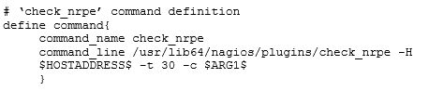 |  | 26
Setup called config file that will point to our server to monitor | Copy /usr/local/nagios/etc/objects/localhost.cfg to the location: /usr/local/nagios/etc/servers.  Rename the file to serverclients.cfg. |  | 27
Edit serverclients.cfg | Change all instances of localhost to the server hostname of the remote host. Change the address under the HOST DEFINITION section to match the IP of the remote host.  Also, comment out all the code in the HOST GROUP DEFINITION section. |  | 28-29
Verify nagios for any errors | Run following command (all in one line):  /usr/local/nagios/bin/nagios -v /usr/local/nagios/etc/nagios.cfg |  | 30
Restart nagios service | Run command: service nagios restart |  | N/A
Configure firewall | To allow nagios server to connect to remote host, run these commands on both servers:  firewall-cmd --permanent --add-port=5666/tcp  firewall-cmd --reload |  | 31-32
Reboot RDMS server | Reboot the remote host to confirm changes. Log back in after reboot. |  | N/A
Test Server/Agent connection | Make sure you are logged into the Nagios server. Return to the Nagios tactical overview section. Confirm the hosts section now lists ‘2 Up’ | Take final snapshots on both servers. | 33

Reference Figures

VM Setup Figures:

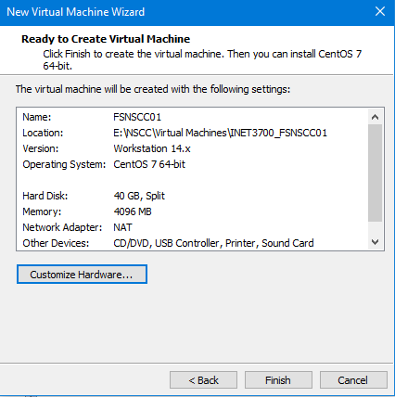
Figure 1: Preferred settings for new virtual machine

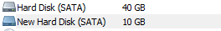
Figure 2: Make sure there are two hard disks configured like this

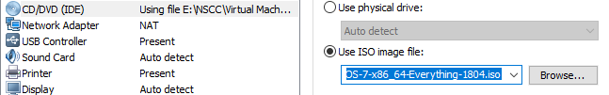
Figure 3: Connect the CentOS7 everything iso to the virtual machine

CentOS Installation Figures:

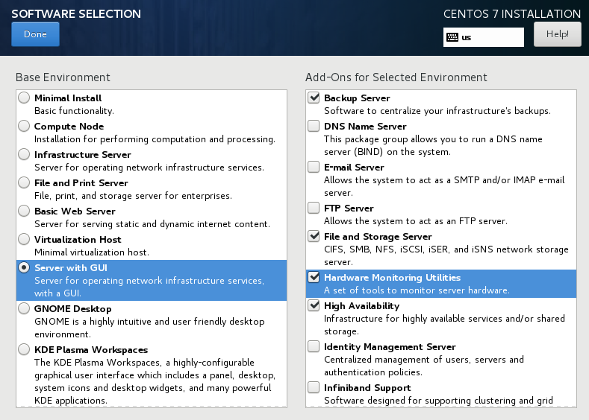
Figure 4: Settings for base environment and add-ons. Not all add-ons selected are shown. Make sure to select all 5 add-ons as per the activity plan
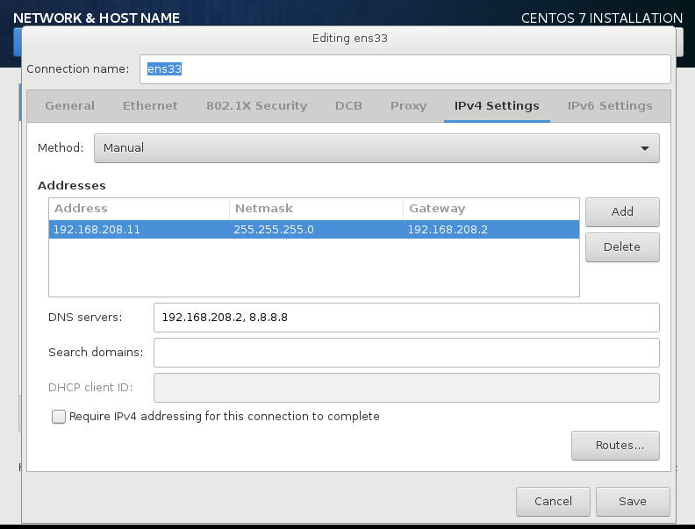
Figure 5: Static IP addressing as per the company inc document.

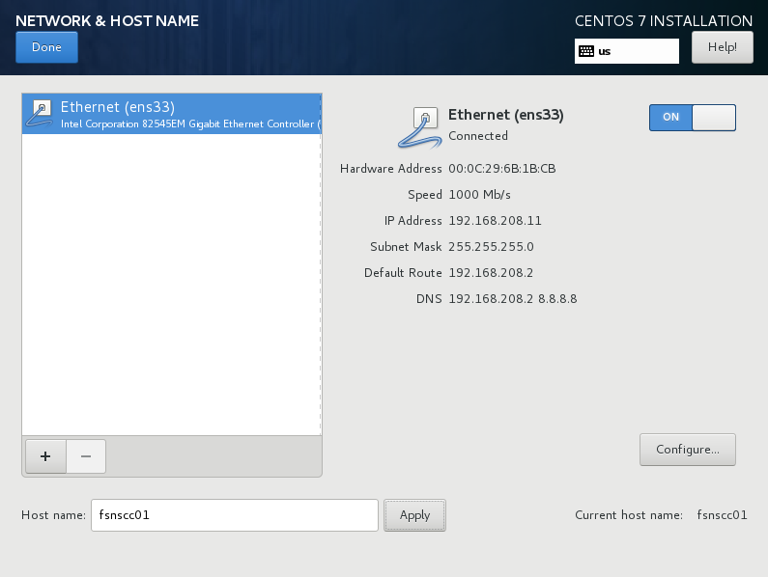
Figure 6: The configured network and hostname

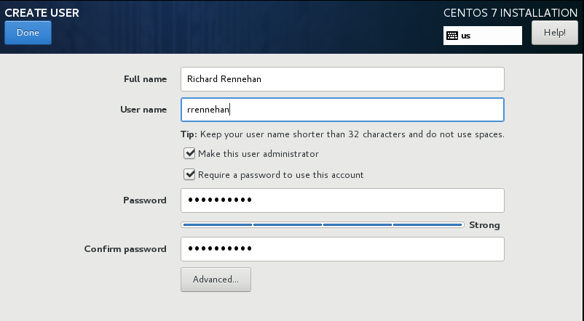
Figure 7: Setting up local administrator account following naming convention.

Samba Setup Figures:

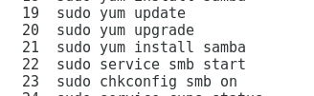
Figure 8: Commands to install samba

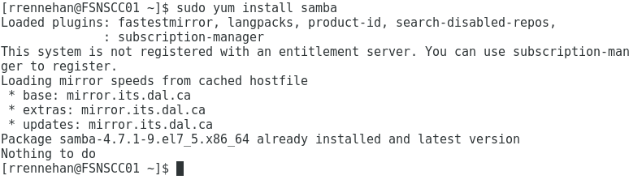
Figure 9: Attempting to install Samba

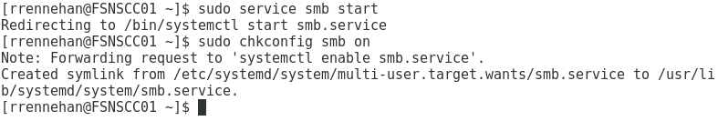
Figure 10: Setting up smb chkconfig

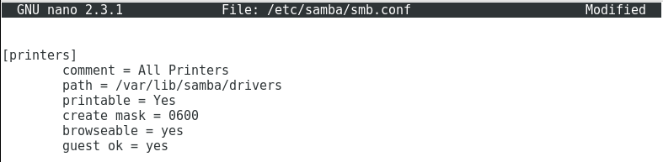
Figure 11: Altering smb.conf to match settings

Cups and Printing Setup Figures

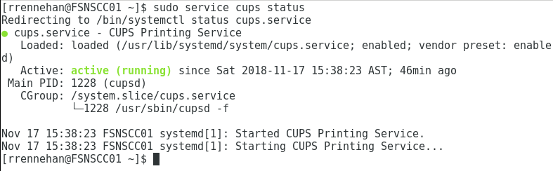
Figure 12: Checking status of cups

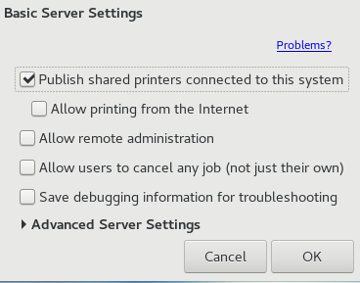
Figure 13: Altering server settings in print settings application

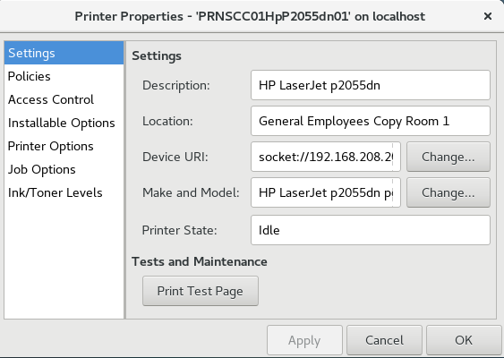
Figure 14: New printer’s properties

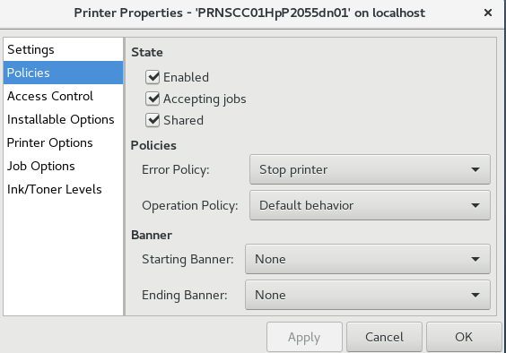
Figure 15: New printer's policies

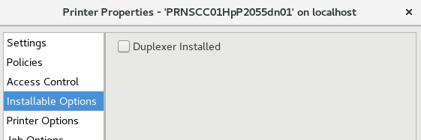
Figure 16: Duplexer not installed on new printer

Nagios Setup Figures

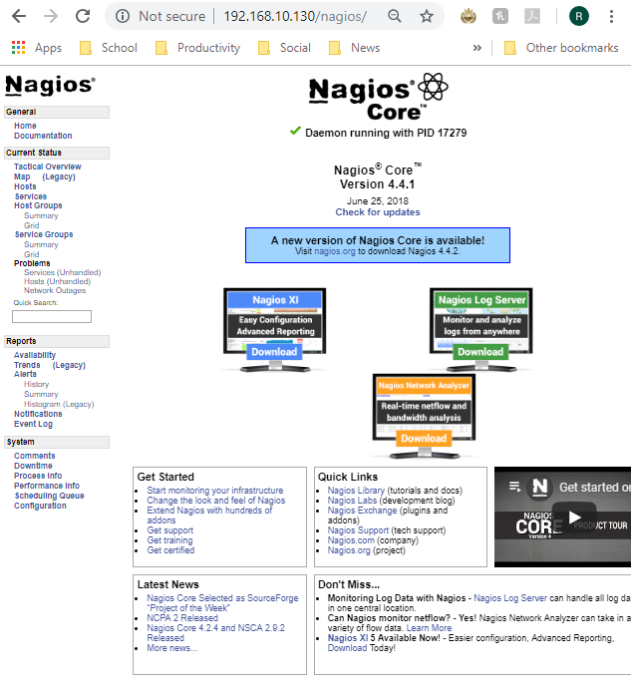
Figure 17: The nagios web interface after installation of Nagios and configuration of nagiosadmin account. Don’t forget to install the Nagios plugins as well.
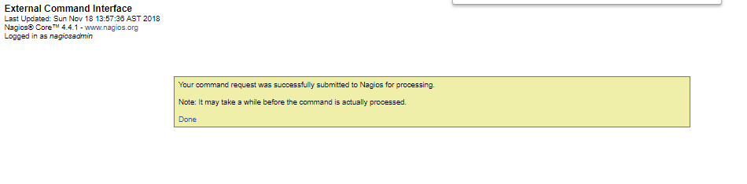
Figure 18: Result of scheduling next check for host after installing Nagios Plugins

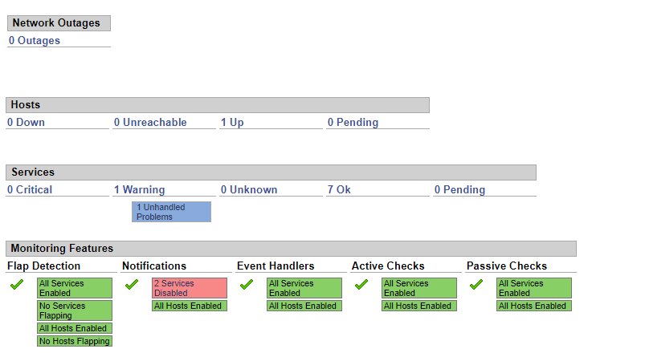
Figure 19: Tactical Overview after fresh installation of Nagios. Confirming which services are running
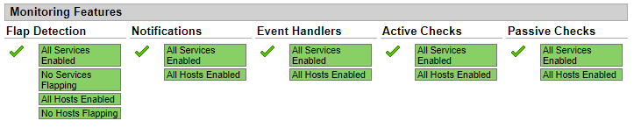
Figure 20: After enabling all services

NRPE Setup Figures

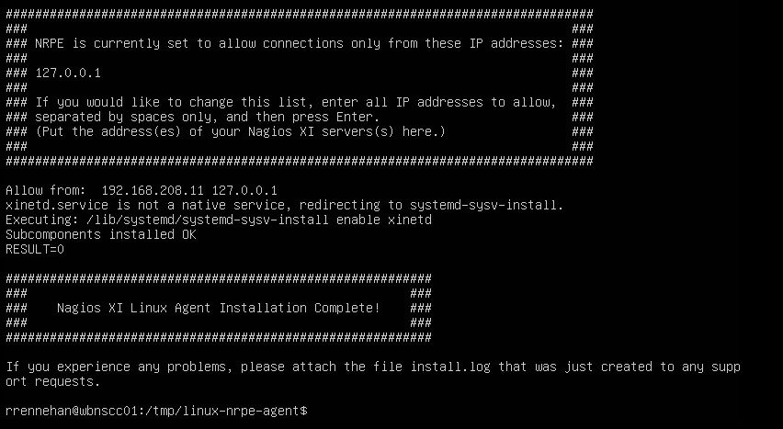Figure 21: Successful installation of NRPE on Ubuntu Server

Figure 22: Checking NRPE version

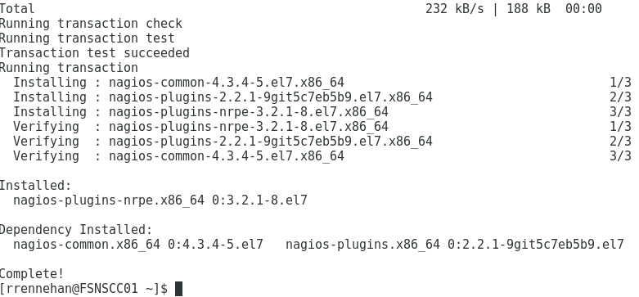
Figure 23: Updating Nagios plug-ins on Nagios server

Connecting Servers Figures

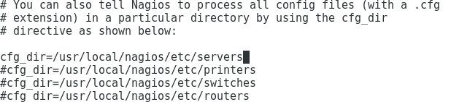
Figure 24: Fixing commented line in nagios.cfg file

Figure 25: Making directory for servers
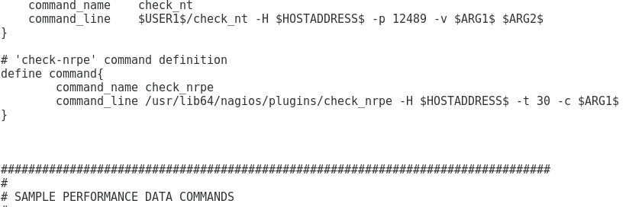
Figure 26: Editing objects.cfg
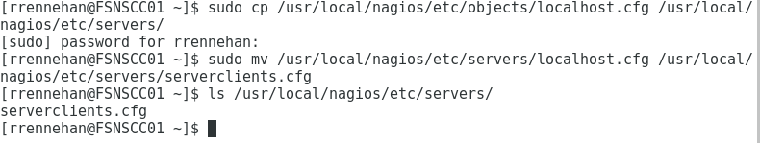
Figure 27: Creating cfg file that will point to the servers to monitor

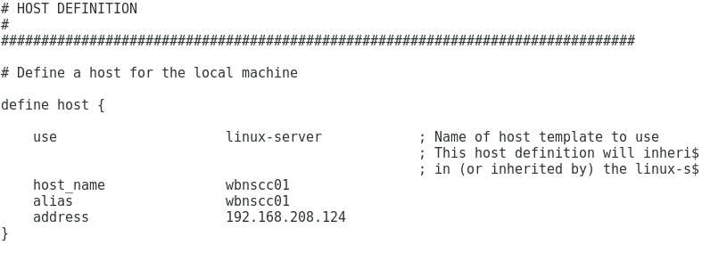
Figure 28: Process of changing serverclients.cfg so all hostnames match remote host

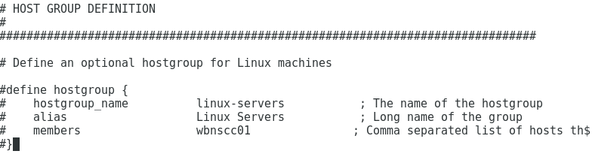
Figure 29: Comment out commands related to HOST GROUP DEFINITION

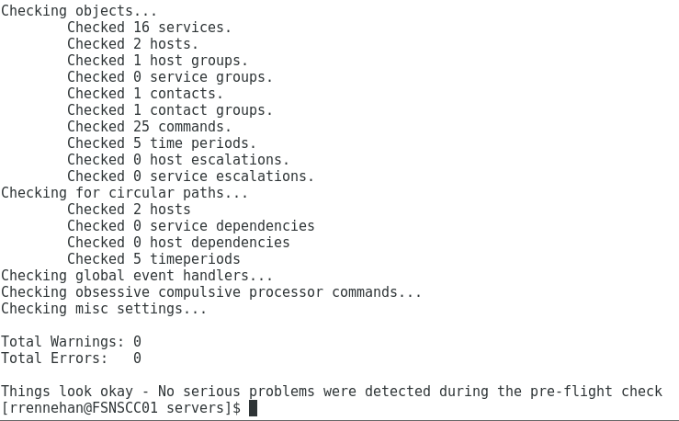
Figure 30: Running /usr/local/nagios/bin/nagios -v /usr/local/nagios/etc/nagios.cfg to check for Nagios errors

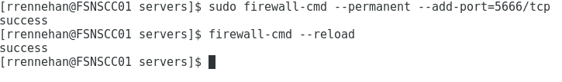
Figure 31: Adding port 5666/tcp on Nagios server
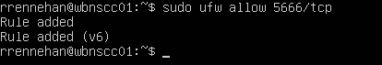
Figure 32: Adding port 5666/tcp on remote server. UFW does not require a reload after adding a rule
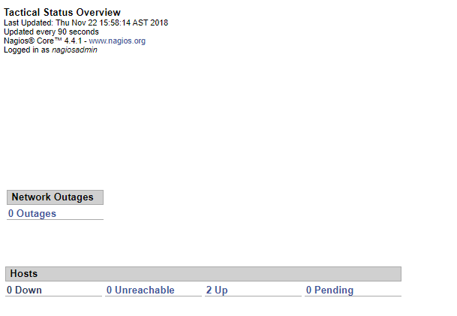
Figure 33: Both servers are up according to the tactical overview

Finishing Touches

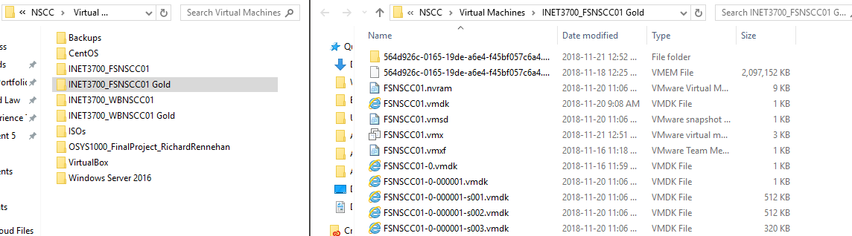
Figure 34: Creation of Gold Copy for Nagios Server. Preferably, store it on a separate drive.

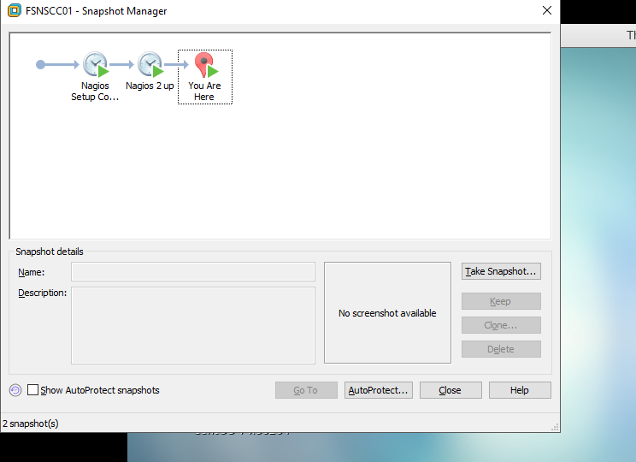
Figure 35: Snapshots taken for the Nagios server so far
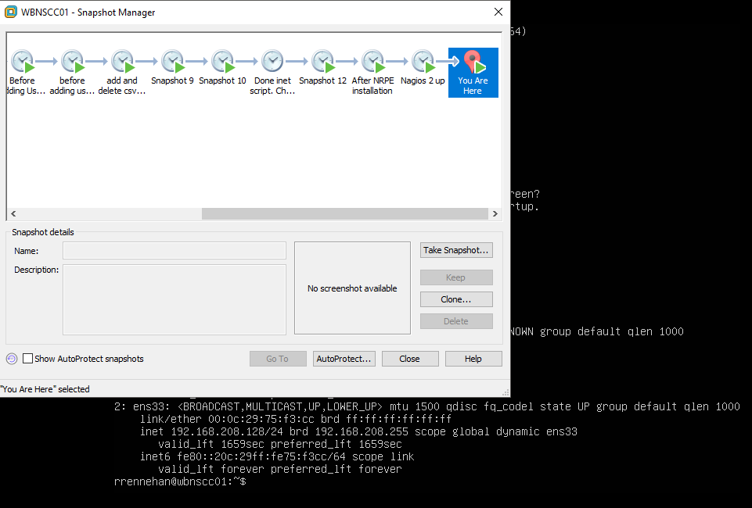
Figure 36: Snapshots on remote server so far

Assignment Questions

- Write a short description on the chkconfig command in CentOS
  - According to the official man page, “chkconfig provides a simple command-line tool for maintaining the /etc/rc[0-6].d directory hierarchy by relieving system administrators of the tasks of directly manipulating the numerous symbolic links in those directories. The chkconfig command is used to add new services for management, removing services from management, listing current startup information for services, changing the startup information for services, and for checking the startup state of a service.
- What are your run levels in CentOS?
  - According to Maurand from liquidweb.com (2017), here’s a list of all run levels in CentOS:
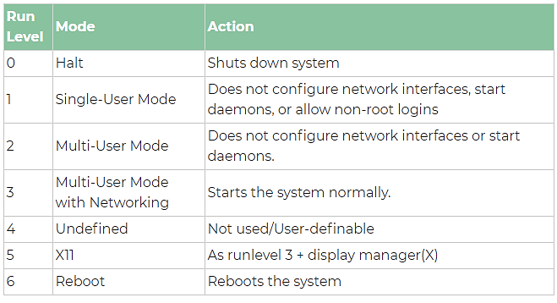
Figure 37: Linux Run Levels. By Maurand (2017)
- What run levels are we setting in our install and why?
  - In our install, we are configuring run levels 2, 3, 4, and 5 with the following command: chkconfig --level 2345 httpd on. This ensures that all normal run levels are compatible. If we need to go into run level 1 or 2, then we can choose whether to start the service by going into run level 1 or level 2.

- Are there any warnings? If yes, specify details including what server is producing the warning
  - Yes. On the Nagios (CentOS) server, there is a warning tied to the HTTP service: HTTP WARNING: HTTP/1.1 403 Forbidden - 5179 bytes in 0.095 second response time
- Are there any notifications? If yes, specify details including what server is producing the notification
  - Here’s a list of all my Nagios notifications:
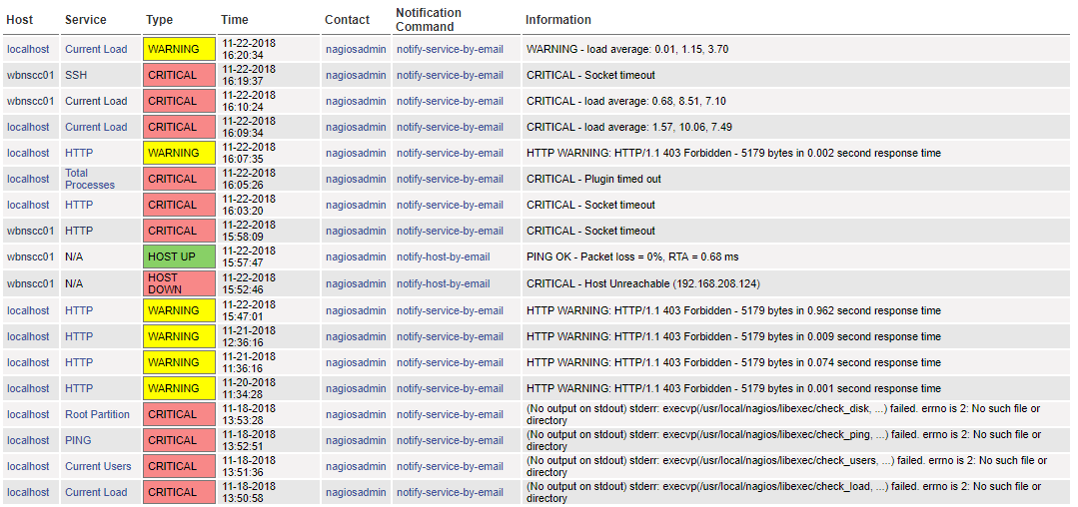
At first, I received a bunch of errors because I accidentally entered the wrong IP address for the remote host.

- Select services from your current status option. What services are being monitored for your identity management server? What services are being monitored for your Nagios server?
  - Here’s the list of services being monitored for both the Nagios server (localhost) and remote host (wbnscc01):
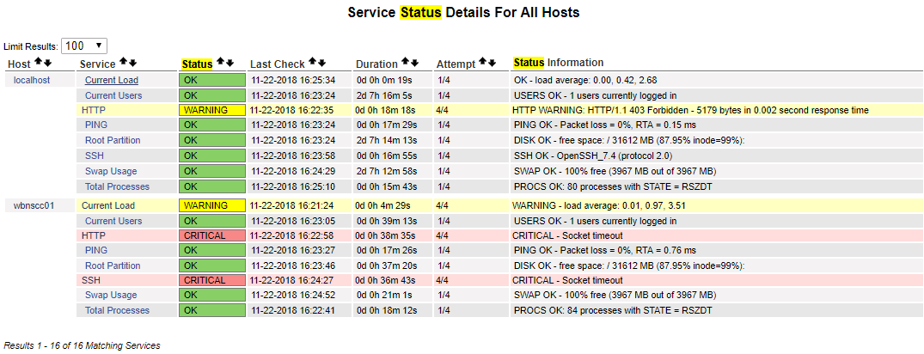

References

Jolson. (2015, May 20). Nagios Core - Installing Nagios Core From Source. Retrieved November 18, 2018, from https://support.nagios.com/kb/article/nagios-core-installing-nagios-core-from-source-96.html#CentOS

Jomann. (2014, December 17). NRPE - How to install NRPE. Retrieved November 21, 2018, from https://support.nagios.com/kb/article/nrpe-how-to-install-nrpe-8.html

Maurand. (2017, October 02). Linux Runlevels Explained. Retrieved from https://www.liquidweb.com/kb/linux-runlevels-explained/

